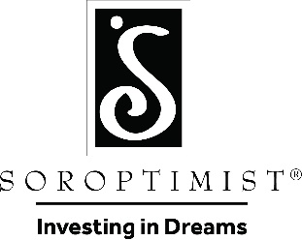
It’s What YOU Do That Counts!
VOLUNTEER
VOLUNTEER
Are you a young woman between the ages of 14 and 18 who volunteers in your community or school? Do you see challenges instead of obstacles? Hope instead of despair? If you are a young woman who believes in the power of
volunteer action, then you may be eligible to win a Violet Richardson Award.

This award recognizes young women who make the community and world a better place through volunteer efforts such as: fighting drugs, crime and violence; cleaning up the environment; and working to end discrimination and poverty.
Volunteer actions that benefit women or girls are particularly encouraged.
Visit Soroptimist Founder Region website: www.si-founderregion.org for more info or click on the link below for the application.

Violet Richardson Award Application Form

For information about applying to the Violet Richardson Award program, please contact:

Soroptimist International of: NOYO SUNRISE

Name TESS ALBIN-SMITH Email TESS@ALUMNI.UCDAVIS.EDU Phone 707-961-1123 Club Application Deadline: DEC 15, 2021

